## **Objectives**

* Explain about ASP.NET Web API POST method
* Explain how EF Database First Approach and ASP.NET Web API can be used to insert data to the SQL Server

In this hands-on lab, you will learn how to:

* Implement an ASP.NET Web API service that inserts data to the SQL Server using EF6 Database First Approach
* Implement the POST method in ASP.NET Web API
* Use Postman to issue Post request to the Web API service

**Prerequisites**

The following is required to complete this hands-on lab:

* Visual Studio 2017 Community Edition
* Web API 2.x
* SQL Server 2014
* Postman

## **Notes**

Estimated time to complete this lab: **90 minutes.**

**Task 1 – Create database table to perform insert operation**

**Note:** Re-use the database schema that you created for the previous exercise if exists, else follow the below steps for creating a new one.

1. Create a database called **StudentDB** in SQL Server
2. Creates the Students table and populate it with some test data as shown in the below image.

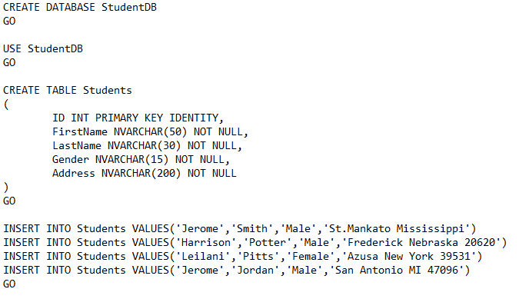

**Task 2-Creating a new ASP.NET Web API Project**

1. Refer previous exercises for creating a new ASP.NET Web API project.
2. Name your Web API project **StudentService**

**Task 3-Adding ADO.NET Entity Data Model to insert data into SQL Server database**

1. Right-click on the Models folder and then select **Add – New Item** option which will open the Add New Item window and from the **“Add New Item”** window select the **“Data”** option from the left pane and from the middle pane select **ADO.NET Entity Data Model**. In the Name text box, type **StudentDataModel** and finally click the **Add** button as shown in the below image.

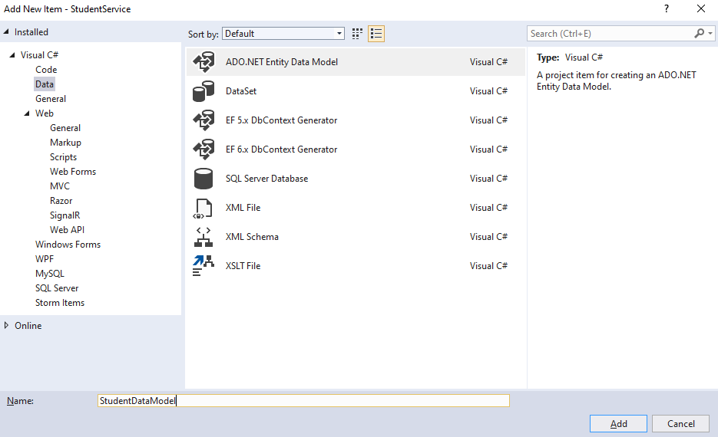

1. Once you click on the **Add** button, it will open the **Entity Data Model Wizard** and from that wizard select “**EF Designer from database”** option and click on the “**Next”** button as shown below.

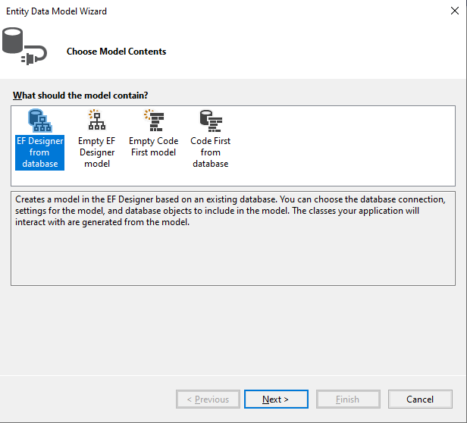

1. On the next screen, click on the “**New Connection**” button
2. Once you click on the **New Connection** Button it will open the **Connection Properties** window. On “**Connection Properties**” window, set

**Server Name =** <your_server_name>

**Authentication =** Select the authentication type

**Select or enter a database name =** StudentDB

Click the **OK** button as shown below.

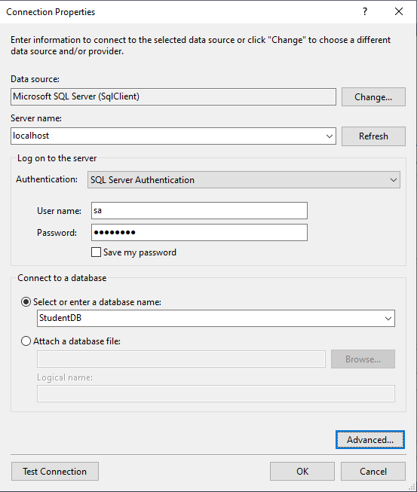

1. Once you click on the **OK** button it will navigate back to the Choose Your Data Connection wizard. Here Modify the Connection String as **StudentDBContext** and click on the Next Button as shown in the below image.

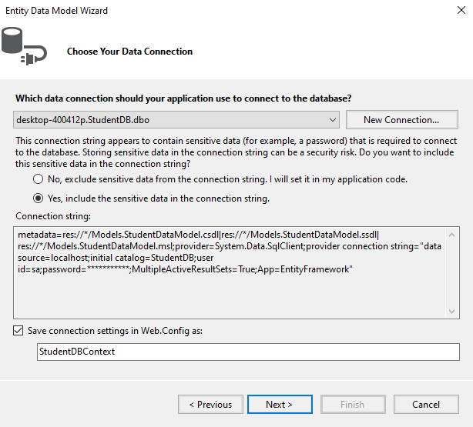

1. On the next screen, make sure that “Entity Framework 6.x” is selected.
2. On Choose Your Database Objects and Settings screen, select the **“Students”** table, provide the model namespace name and click on Finish button as shown below.

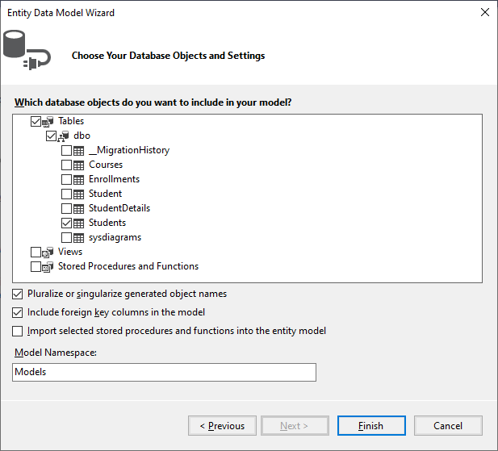

1. Once you click on the Finish Button the following edmx file will be generated within the Models folder as shown below.

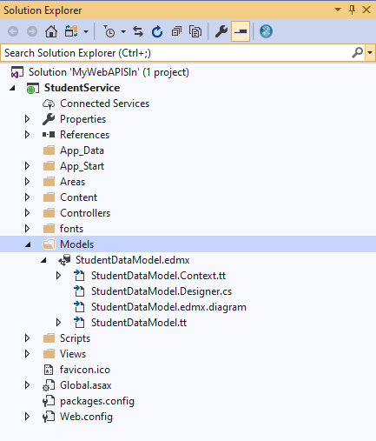

##### Task 4 - ****Adding Web API Controller****

##### Right-click on the Controllers folder and select****Add – Controller****option and then select “****Web API 2 Controller – Empty****” and click on the “****Add****” button as shown below.

##### 

1. On the next screen set, the Controller Name as **StudentsController** and click on the **Add** button as shown in the below image.

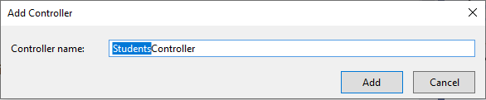

##### Task 5 - ****Implementing the POST method in ASP.NET Web API****

##### Add the following code in StudentsController.cs

##### 

**Task 6 – Run your application and observe the result using a Web API client tool like Postman**

1. Set the HTTP verb to **POST**
2. In the Request **Body**, include the student object that we want to add to the Students database table in **JSON** format
3. Finally, click on the **Send** button as shown below

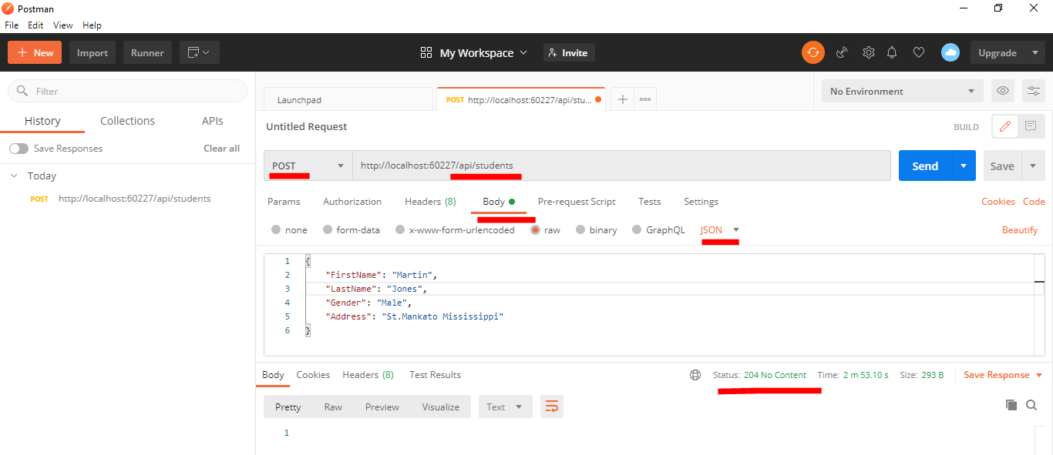

1. It will be working fine and adds the student to the database as expected. Since the return type of the Post method is void, we get status **code 204 No Content**. As per REST standard, when a new item is created, it should return the status code **201 Item Created.**
2. Modify your Post action as shown below in order to achieve the above goal.

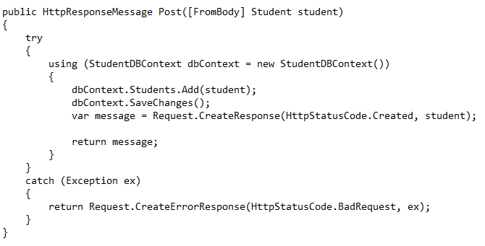

1. After modifying the code, rebuild your API Project and execute again.
2. Verify whether you are getting the response as expected as shown in the below picture.

